Full name: ……………………………… | Class:…………….
English worksheet
Unit 14: Are there any posters in the room?
I. Write the name of the objects in the picture.
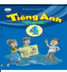 | 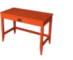 | 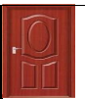 | 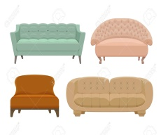
1. ……… | 2. ……… | 3. ……… | 4. …………. | 5. …………
II. Circle a or b.
1. Where’s the ……… ? a. ball b. balls
2.Where’re the chairs? ……… in the kitchen. a. They’re b. It’s
3. ……… a book on the desk? - Yes, there is. a. Is there b. Are there
4. Are there posters on the wall?- No, ……… a. there are b. there aren’t.
5. There ……… flowers in the room. a. is b. are
III. Look at the picture and write.
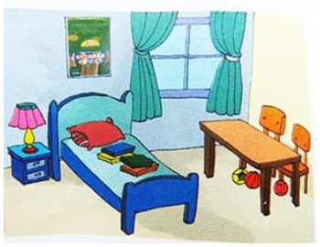
- This is my bedroom. There is a bed …….. the room.
- There is a table, too. There …… two chairs ……. The table.
- There are some …… on the bed.
- There are some balls …….. the table.
- There ……… a ………. on the wall.
- There is a ……. on the small table.
- Are there any curtains in the room? …….. …….. ……..
- Are there any wardrobes in the room? …….. …….. ……..
- The lamp is …… ……. The bed.
- Is there a vase of flowers in the room? No, there ………

