ENGLISH – GRADE 3
UNIT 13 – LESSON 1
Task 1. Look and write. There is one example.

Example:  optres → p o s t e r | 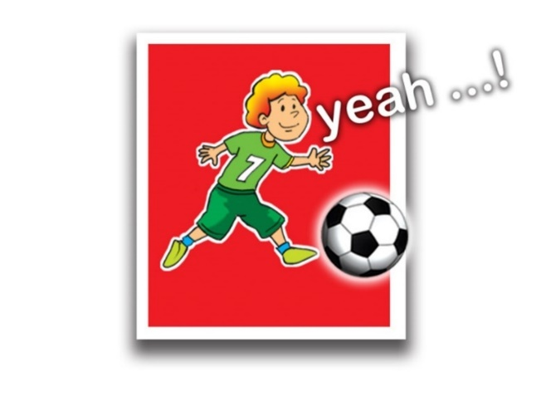

1. irahc → c __ __ __ __ | 2. atco→ c __ __ __ | 3. rodo → d __ __ __
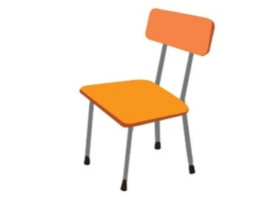 | 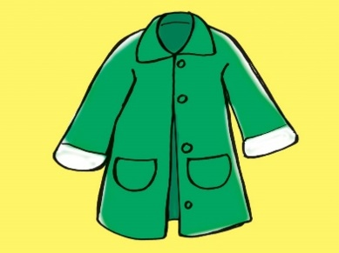 | 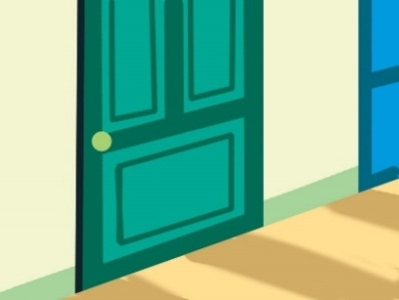
4. labet → t __ __ __ __ | 5. labl → b __ __ __
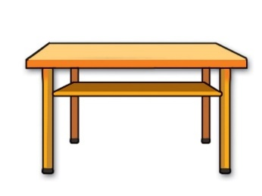

Task 2. Reorder the words
1.colour/ is/ ruler/ what/ the ? …………………………………………………….
2.how/ father/ is/ old/ your? …………………………………………………….
3.yellow/ the/ is/ bag/ school. …………………………………………………….
4.is/ where/ book/ the? …………………………………………………….
5.rubber/ here/ is/ my. …………………………………………………….
Task 3. Read and complete. There is one example (0).
a.house | b.isn’t | c.it | d.garden | e.nice | f.there

A: This is my (0) house.
B: Wow. It's very (1) _____________________
A: Yes, (2) ____________________ is. And this is my bedroom.
B: It's so big! Is there a (3) _____________________?
A: Yes, (4)__________________ is. Come and see it.
B: Is there a pond in the garden?
A: No, there (5)____________________.

Task 4. Look, read and circle the correct picture.
1. A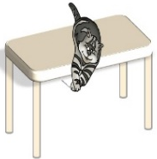 B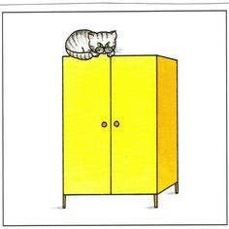  2. A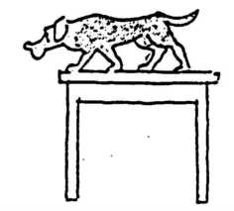 B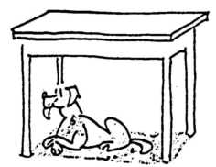  3. A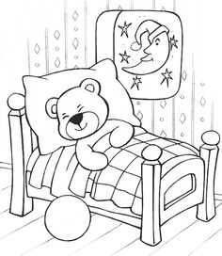 B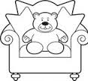 | 1.The cat is on the closet.  3. The dog is on the table.  4. The teddy bear is on the bed.

